Sickle cell anaemia
Cells in tissues need a steady supply of oxygen to work well. Normally, haemoglobin in red blood cells takes up oxygen in the lungs and carries it to all the tissues of the body.
Red blood cells that contain normal haemoglobin have a biconcave shape (like a doughnut without a hole). This shape allows the cells to be flexible so that they can move through large and small blood vessels to deliver oxygen.
Sickle haemoglobin is not like normal haemoglobin. It can form stiff rods within the red cell, changing it into a crescent, or sickle shape.
Sickle-shaped cells are not flexible and can stick to vessel walls, causing a blockage that slows or stops the flow of blood. When this happens, oxygen can’t reach nearby tissues.

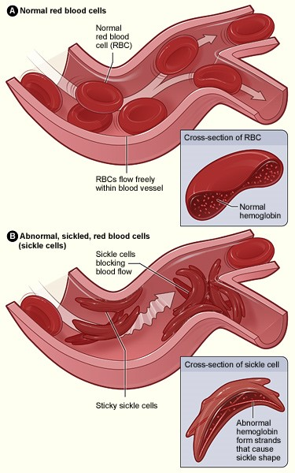
Normal Red Cells and Sickle Red Cells

Figure A shows normal red blood cells flowing freely in a blood vessel. The inset image shows a cross-section of a normal red blood cell with normal haemoglobin.

Figure B shows abnormal, sickled red blood cells blocking blood flow in a blood vessel. The inset image shows a cross-section of a sickle cell with abnormal (sickle) haemoglobin forming abnormal stiff rods.

